evaluating strategies to promotE sea turtle conservation | Introduction to Modeling (in Stella)  CPaT, Modeling/Stats Spring 2013  Judy Cushing and Aaron Skomra  Adapted from the lab by Steven K. Rice

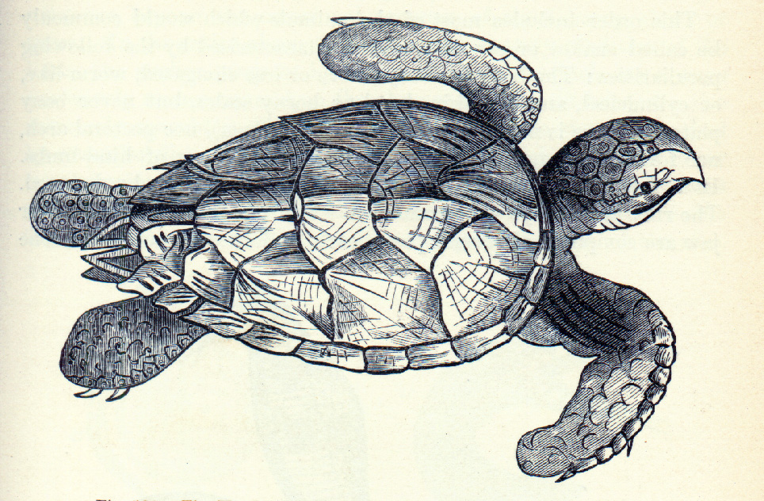Figure 1. A hawksbill sea turtle (Nicholson 1889. Text-Book of Zoology. D. Appleton and Company, New York).

Part I. Study the Problem. Like many sea turtles worldwide (Figure 1), loggerhead sea turtle (Caretta caretta) populations are declining by approximately three percent annually and the species is currently provided federally threatened status. Two potentially beneficial strategies could boost loggerhead populations. First, conservation groups have successfully limited access to beaches during the time when females lay their eggs and have thereby lowered mortality of eggs and hatchlings. Second, the National Marine Fisheries Service has devised a technology, the Trawl Efficiency or Turtle Excluder Device (TED), that virtually eliminates juvenile and adult mortality due to incidental capture and drowning in shrimp and fish trawls. Each of these strategies requires effort and expense. Thus, it is essential to evaluate the relative merits of the two conservation measures. However, loggerhead turtles are large, long lived (maximal life span is approximately 54 years and reproduction begins around age 22) and require extensive areas of open ocean. Therefore, it is difficult to design and carry out short-term, controlled experiments to test hypotheses about the effects of management strategies on the long-term health of loggerhead populations.

In cases where hypotheses might be difficult to test with experiments, dynamic simulation models are often used to explore predictions that follow from hypotheses. Such models are based on an understanding of the underlying processes that control the variables of interest. For example in the absence of experiments designed to understand the effects of the two loggerhead management scenarios, biologists have developed population models that have been used to explore the consequences of the two strategies. In lab today, you will develop a dynamic simulation model of loggerhead sea turtle populations and you will explore the consequences of the two management options suggested above.

Population Decline in Loggerhead Sea Turtles

Although loggerhead sea turtles are the most common marine turtles occurring on the southeastern coast of the United States, their three percent annual decline in population is cause for concern. As discussed in the introduction, two main threats to the population persist. First, following egg laying, raccoons, gray foxes and ghost crabs prey upon eggs and hatchlings and their damage can be partly avoided with beach surveillance programs. For example, Bald Head Island has the highest concentration of rookeries in North Carolina. Nests there have been protected since 1982 and overall hatchling success has increased from less than 20% to more than 60% during that time (Palmer and Braswell 1995. Reptiles of North Carolina, UNC-Chapel Hill Press). Second, mortality from trawling activities reduces adult population sizes, but the consequences of this remain largely unknown. Evidence suggests that the effect might be great. Near Bald Head Island, 30 to 47 individual turtles washed ashore within ten days following the stringing of one mile of gill nets; however the question remains: which is a more effective management practice, protecting nests or reducing adult mortality in nets? Given the lack of long-term experimental data, biologists have used short-term estimates of population variables and developed simulation models to assess the outcomes of different invasive actions. In this exercise, you will familiarize yourself with the computer modeling program STELLA and employ that software to develop a simulation model that will allow you to investigate the dynamics of loggerhead sea turtle populations.

In the space provided on the (separate)Student Lab Report template, write null and alternative hypotheses that might explain the outcomes of the various management scenarios. You can use the space below as scratch space! If you are unfamiliar with these terms see the paragraph below.

More on hypotheses: A hypothesis is a tentative explanation for a group of observations. The most useful hypotheses are ones that enable you to make predictions that can be tested. One important property of hypotheses is that they can be eliminated by tests, but not confirmed with certainty. Put another way, you can reject a hypothesis, or you can accept it as the best among a group of hypotheses, but you can never prove that a hypothesis is correct without doubt. Thus, it is often useful to begin with two contrasting hypotheses often called the null and alternative hypotheses. The former usually describes the control situation; it is also known as the hypothesis of no effect. The latter reflects the hypothesis that predicts the choice you view as most likely. Note that these contrasting hypotheses are set up so that when tested and one hypothesis is rejected, the other hypothesis remains as a tentative explanation.

Modeling with STELLA

The STELLA modeling software is a flexible, powerful tool that will allow you to develop dynamic simulations that retain enough reality to be usefully applied to the biological systems you will study. See the program web site for a “Quick Help Guide” to the software. This will be extremely useful after you get going. However, to get you started programming, you can familiarize yourself with the modeling approach using the tutorial below. The tutorial will help you design a simple population growth model for loggerhead sea turtles.

Part II. Familiarize yourself with the Tools you will use for modeling: Building a Simple Model Using STELLA

Before you begin, open the STELLA software from Start Menu. Once you are “in” Stella, make sure you understand about how to navigate to your workspace on the fileshare, so you will be able to save your model(s)!

General features of STELLA
The STELLA software package is a modeling tool that will allow you to build realistic simulation models. However, to begin your modeling effort, you must first identify the important “players”. This exercise will walk you through a simple model that can be used to investigate population change in the loggerhead sea turtle. Thus, the important “player” is the sea turtle, or more specifically, the population of sea turtles. The population will exist in what will be referred to as a “stock”. This stock retains the number of individuals in the population. Stocks can have input and output flows (births, immigrations and deaths and emigrations) and controlling variables that affect these inputs and outputs. The four model building blocks allow you to do these and are described below.

Model Building Blocks
Stocks: The basic building block is the stock which is used to represent anything that accumulates (populations, biomass, nutrients, water). These are tangible, countable, physical accumulations. You can also use stocks to represent the degree of non-physical accumulations such as knowledge or fear.

Flows: The second building block is the flow which is used to represent activities that lead to inputs and outputs. Flows include births, migration and nutrient or biomass transport. These activities will change the magnitude of stocks in the system. You can think of flows as being pipes. Whatever is associated with the stock(s) flows through them and causes the magnitude of stock(s) to increase or decrease. The circular portion represents the regulator and contains an algebraic expression that controls the volume of flow through the pipe.

Connectors: Connectors look like wires and transmit information that regulate flows. Connectors can connect into flows or converters but never into stocks. Only flows affect the magnitude of stocks. However, connectors can affect both input and output flows.

Converters: Converters contain equations that generate an output value during each time interval of a simulation. Converters often take in information and transform it for use by another variable in the model. They are also handy for storing constant values.

Sorry – the screen shots below are for Stella 8.1.1, so will look slightly different from what we are using (9.1)

Now, proceed with your first modeling effort. The first stage is to map out the scheme of relationships that affect the stock of interest. Be sure you are in map “mode” before you begin. Stella has four “modes” (Interface, Map, Model, and Equation). You switch between them using the tabs to the left of the window.
The building blocks are found in the upper left side of the toolbar and look like: Use the building blocks to construct the map shown below. See the Quick Help Guide if you encounter problems http://biology.kenyon.edu/courses/ENVS%20112/Assignments/StellaTutorial.html .

Helpful hints
1. Rename blocks by clicking on the blocks and typing in the new name.

2. If you make a mistake, use the dynamite tool to blow it up. Do this by clicking on the dynamite stick and placing it over the item and clicking again.

3. If you hold down the <alt> key, the last building block you used will be retained.

4. Save your model in your workspace, using the name: loggerhead-SAP

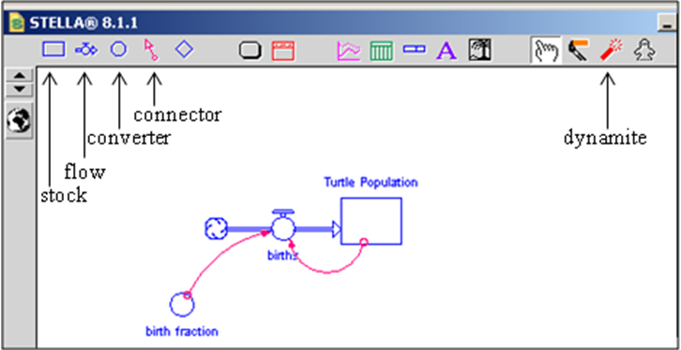

Now that you’ve developed the map, it is time to use it to simulate population change in the sea turtle. The STELLA software has already developed the equation framework necessary to perform the simulations. You, however, have to establish the specific relationships and set the initial parameter values. To begin, click on the “Model” tab and it will put you into modeling mode. You will notice that a question mark now resides in each stock, flow and converter in your model. Each “?” indicates that information is required before the model can be run. The model needs to know the initial value in each stock and the relationships that define the flows and the information that travels along the connectors. Defining these will be illustrated as you construct them on your model.

First consider the control of the turtle_population. In the model, this is controlled by the births. Double click on the births flow regulator (the circle attached to the pipe). Notice that both turtle_population and birth_fraction appear in the Required Inputs list. Stella recognizes that they belong there because you used connectors to indicate that each of these variables serve an input to births, and requires that each be used as an input. Define births as:

turtle_population * birth_fraction

Do this by single-clicking on the respective variables in the Required Inputs list. Follow the first with the asterisk (*) to indicate the multiplication function. The figure should look like the one below. When it does, click OK.

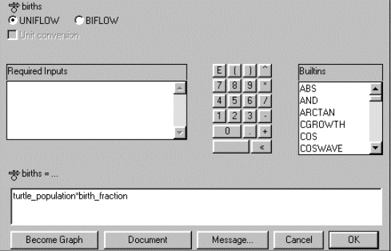

Next, determine an initial value for the turtle _population. Double-click on the turtle_population stock and the dialogue will allow you to place a value in the white box. To initialize turtle population, click in or type “100”. Click OK.

Finally, to define birth_fraction double-click on the birth_fraction converter. Type in 0.2 which will indicate that there are 2 births for every 10 individuals.

Running the Simulation
Now that the model is constructed, you can explore its dynamics. Before you do that, you will need a way to view the results of the simulation. Select the graph pad icon from the toolbar.

Single-click anywhere on the white space in the diagram to deposit the graph pad. The graph pad will automatically open up, revealing a blank Graph Pad page. Double-click anywhere on the page and you will see a dialogue. Move turtle_population to the “Selected” column highlighting it and using the arrow (>>). Click OK.

Pull down the Run menu and select “Run” (^R). Watch the graph of turtle population unfold over time. Note that you can also select “Run Specs…” to change the defaulted length of the simulation, time step, or other parameters.

Now, manipulate the_birth fraction, and put its output in another graph. Compare the two graphs to see how this influences the outcome.

In the space provided on the (separate) lab report sheet, answer the questions:

Is this model realistic?

Why or why not?

This simple model has introduced you to some of the features of the STELLA software. Now, continue with the exercise (Part III) and build a more realistic model of population dynamics.
Part III. Evaluating Management Strategies for the Loggerhead Sea Turtle

Part IIIa. Extending the Simple as Possible Population Model. The model you just developed has limited use for the problem at hand. Do you see why? To understand how variation in mortality within different life stages affects the overall population size, you will need a more complicated model that includes mortality and birth rates for different life stage classes. Fortunately, this information is available (Table 1) from short-term mark and recapture studies. Note that ages are difficult to determine and the model you produce will be a size-class rather than an age-class model. Also notice that the sum of those growing to the next stage and those dying does not equal one except for the first stage. The difference between that sum and unity represents the fraction that survive and remain in that stage class.
You will find it easiest to start from scratch, rather than use your “simple as possible” model!

Stage Number | Class | Size  (cm) | Approx. Ages  (yr)  y | proportion growing  to next stage  G | mortality rate  proportion die/year  D | Fecundity  # eggs/indiv/yr
1 | eggs, hatchlings | <10 | <1 | 0.675 | 0.325 | 0
2 | juveniles | 10.1-87.0 | 1-21 | 0.000384 | 0.268 | 0
3 | adults | >87.0 | 22-54 | 0.000 | 0.191 | 80
Table 1. Stage-based life history for loggerhead sea turtle. Adapted from Crouse et al. 1987. Ecology, 68: 1412.

Each stage should be treated as a separate stock with the essential flows and connectors. In order to assess the population as a whole, create a converter that sums the populations of all stages. This is the item to graph.

Design and implement in Stella a model using the parameters in Table 1 to set flows and connectors and set the initial population of each stage at 10. Run the model for 200 time units. In the space provided on the (separate) lab report sheet, answer the questions to Part IIIa of the lab report, i.e., Is the population increasing, decreasing or remaining constant?

Part IIIb. Designing and running a sensitivity analysis on your new model. Manipulate the various stages by reducing their mortality rates by 50%. When you alter the mortality rate by 50%, it will also affect the proportion of that class growing into the next stage. The consequences of this vary for each stage class. In stage 1 every individual that survives grows to the next stage. So, after reducing the mortality by 50%, merely add that amount to the proportion growing to the next stage. For stage 3, you do not have to be concerned with the proportion moving to the next stage because there is no stage class above it. However, for stage 2 you will have to change the proportion that grow to the next stage when you change the mortality. This is due to the greater survival within the class and, thus, a higher percentage making it through the class to the next stage. The appropriate value is shown in the table below. This type of manipulation where you explore how sensitive the outcome is to variation in the model parameters is called a “sensitivity analysis”.

In the space provided on the (separate) lab report sheet, answer the questions about changing the parameters to your model of the lab report. Then perform the simulation by decreasing the mortality of each stage class by 50%, one stage at a time. The values you will need are provided in the table below. Note that the numbers in bold are those that differ from the initial run. Run the simulation for 200 time units and record the results in the table below:

Simulation parameters | stage 1 | G  stage 2 | stage 3 | stage 1 | D  stage 2 | stage 3 | Population size  at 200 time units
values from table 2 | 0.675 | 0.000384 | 0.00 | 0.325 | 0.268 | 0.191
50% decrease in D-stage 1 | 0.838 | 0.000384 | 0.00 | 0.162 | 0.268 | 0.191
50% decrease in D-stage 2 | 0.675 | 0.00653 | 0.00 | 0.325 | 0.134 | 0.191
50% decrease in D-stage 3 | 0.675 | 0.000384 | 0.00 | 0.325 | 0.268 | 0.0950

Dept. of Biological Sciences, Union College, Schenectady, NY 12308. We gratefully acknowledge Prof. Rice’s permission to use this lab at Evergreen. Any errors in or suggestions for this version should be reported to Judy Cushing, judyc@evergreen.edu. Prof. Rice, as original author retains all rights to the exercise or portions of it, which may be copied and used for educational purposes if distributed free of charge and author is acknowledged.
See section 6.4 in Caswell 2001. Matrix Population Models, 2nd ed. Sinauer.

